# Overview

<https://documentation.sas.com/doc/en/pgmsascdc/9.4_3.4/statug/statug_glm_examples02.htm>

# SAS Code

/* Regression with Mileage Data --------------------------------*/

title 'Gasoline Mileage Experiment';

**data** mileage;

input mph mpg @@;

datalines;

20 15.4

30 20.2

40 25.7

50 26.2 50 26.6 50 27.4

55 .

60 24.8

;

**proc** **glm**;

model mpg=mph mph*mph / p clm;

**run**;

**quit**;

# R Code

library(tidyverse)

library(broom)

# changed block to be a character variable so the aov()

# function treated it as a class variable.

mileage <- tribble(

~mph, ~mpg,

20,

15.4,

30,

20.2,

40 ,

25.7,

50 ,

26.2,

50 ,

26.6,

50 ,

27.4,

55 ,

NA,

60 ,

24.8

) %>%

mutate(mph_sq = mph^2)

lm1 <- lm(mpg ~ mph + mph_sq, data = mileage) %>%

print()

summary(lm1)

augment(lm1)

glance(lm1)

# Results

## SAS

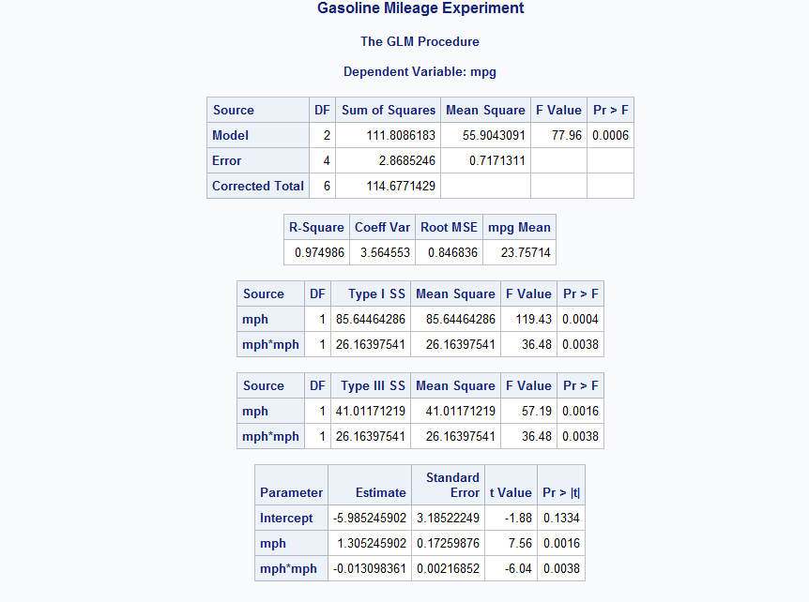

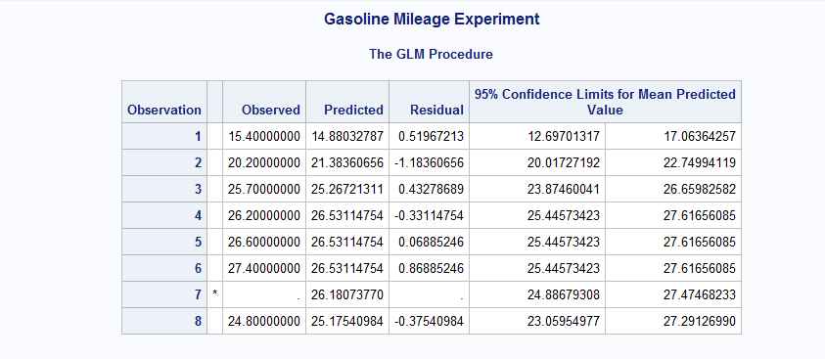

## R

